SUPERSTORE SALES
KPI - total sales ,total profit, sales and profit in % total product count
pie chart segment wise slaes
sales and profit trend line order date
colmn chart category sales
top 5 product based on profit
table : customerid, total sales ,salesin %
slicer: region, ship mode, category
map sales state

Project: 1 Project - In United States, there are many stores in which a survey was conducted based on students i.e. how much they are spending on different kind of purchases like Video games, Indoor games, Toys, Books, Gadgets etc. In the data set (Student Survey), Store setting is the column that explains the Type of location in which the store is present. By using data set (Student Survey), try to extract the meaningful Insights.

Industry Type – Retail Store
Data set - Student survey https://docs.google.com/spreadsheets/d/19PAZIJ7T2pvf50t94_R5tZCiog_aaP24/edit?usp=sharing&ouid=113177982973203432452&rtpof=true&sd=true
Problem Statement- Create a Power BI Report: 1. Tabular Visualization - Format the total amount of purchase (TAP) based on ‘Store location’ and ‘Store setting’: -
- If 0<TAP<35000, then records should be in red color •
- If 35000<=TAP<60000, then records should be in yellow color
- If TAP>=60000, then records should be in Blue color

2 Matrix Visualization – Create Matrix Visualization to show the amount spent on Outdoor sports across different ages and ‘Store setting’. Do the color formatting for the amount spent in total outdoor sports.
3. Funnel chart – Create a Funnel chart to show Total amount of purchase by ‘Store setting’. Show the data labels as Percentage of First.
4. Pie chart – Show the total amount of purchase by different ‘Store location’ for Suburban ‘Store setting’ only. Hint: Use Filter context
5. a) Scatter plot - Video games purchase and Outdoor sports spent across the different ages. b) any plot - Indoor sports and Video games spent across the different age groups.
6. Restrict data access for the given users in User mapping table. For ex. Mani deals with Rural area only so she should be able to view the data which belongs to Rural only, not urban and suburban data.
7. Publish the report on Power BI cloud service and Design the Master Dashboard consisting of Funnel chart and scatter plots. Then create a schedule refresh for six times in every 4 hours for the Dashboard in a day.
8. Use Q&A feature of Power BI –
a) To show average age of students
b) Donut chart for total amount of purchases by ‘Store location

CALCULATE TABLE,RANKx,SELECTEDVALUE,SUMMERIZE,TOPN
IF and Switch in DAX
totsales
avg sales
profit
count
chart
line monthly trends
column chart cateogry wise
map state wise sales
pie region wise profit
table sub categores wies sales , profit ,profit %
fillter
segemt
city
ship mode

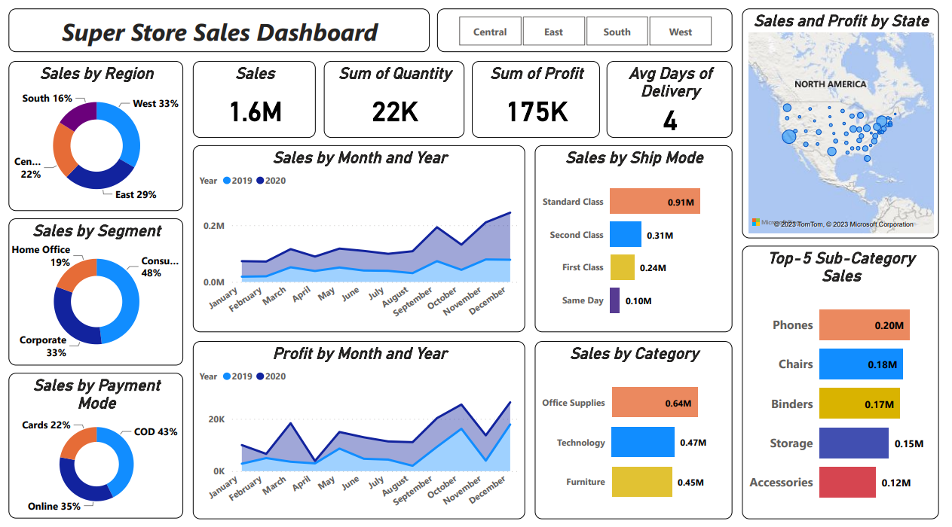
https://mavenanalytics.io/project/9002

https://www.pexels.com/search/gradient%20background/
https://metricalist.com/powerbi-solutions/global-superstore-dashboard/

